# **Project.B**

Introduction

The North American river otter’s taxonomic designation is Lontra Canadensis and it recently adjusted to Lutra Canadensis. Research shows and suggests that they spending at least 11% to 48% of their day on grooming, which is a critical social behaviour among peers. However, various factors related to the grooming remain unstudied, based on the current dataset, I would try to explore those factors on aggregating ways and more granular levels. Since different groups of dataset contain particular information, for example, siblings as blood relation, subadult and young adult as age effect and etc. To answer those four questions and also explore dataset, I would analyse them all by groups and then dissect them by every single factor. Another important concern is that unequal observed time and it results in uneven frequency .In other words, biased measurement would be a concern as larger observed time lead to higher frequency. If comparison are analysed within same group, that should be fine, however, when analysis comes across groups, I introduce a new variable that is also mentioned in the questions, the grooming rate. With that said, the following part is the main analysis contains couples of sub-analysis and then followed by conclusion with my final finding.

Main Analysis

Aggregation Analysis

Section A. Frequency of being a groomer and being a groomee within the same group.

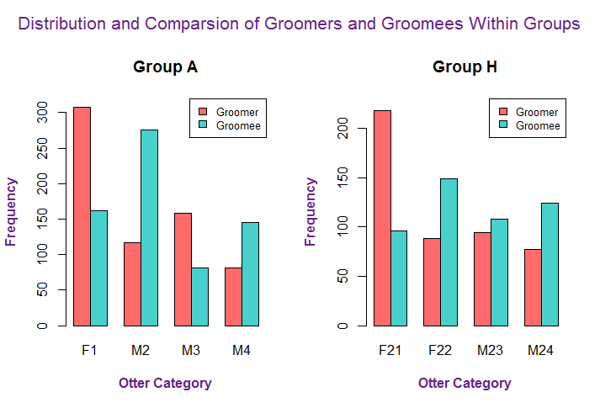

C:\Users\u5102619\AppData\Local\Microsoft\Windows\INetCache\Content.Word\legend.pngC:\Users\u5102619\AppData\Local\Microsoft\Windows\INetCache\Content.Word\legend.png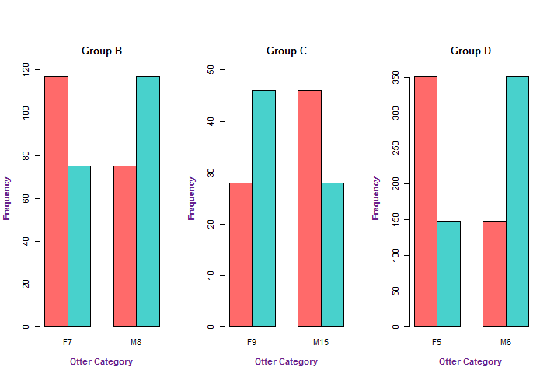

To answer the first question, in regard of grooming and being groomed within the groups, it is reasonable to separate them by groups and then identify each category in each group as a groomer and a groomee, in order to observe their grooming and being groomed frequency. In this case, it is suggested to only use frequency as a comparison benchmark since we are trying to demonstrate patterns within its own group. In other words, the time that they are being observed is the same in its own group. While in following sections, when it comes to comparisons across different groups, there would be the grooming rate introduced. According to above graph, it is suggested that unequal or uneven frequency of grooming and being groomed of all groups. All the red columns stand for when underneath category is groomers and greed ones represent when they are groomees without consideration of breeding or other effects. From group A, there are more male otters than female otters, and in this case, female otter tends to be a groomer when it stays with multiple male otters. Without sufficient information of how groups are formed, I could only presume female otter might regard grooming as behaviour to approach for reproduction. From group H, male is also tend to be a groomee instead of groomer. Group B and Group D shows opposite pattern, in Group B and D, female otters tend to be groomers. While in Group C, male otters tend to be groomers. While Group D mixed with sibling effect, all these effect would be isolate and analysed in the following sections. In this part, I aggregately analyse grooming by group only in despite of some mixed effect. It answers the question that none of them are groomed equally within a group, and finding also indicates female otters tend to play a role as groomers.

Section B. Preference of individuals within multi-member groups

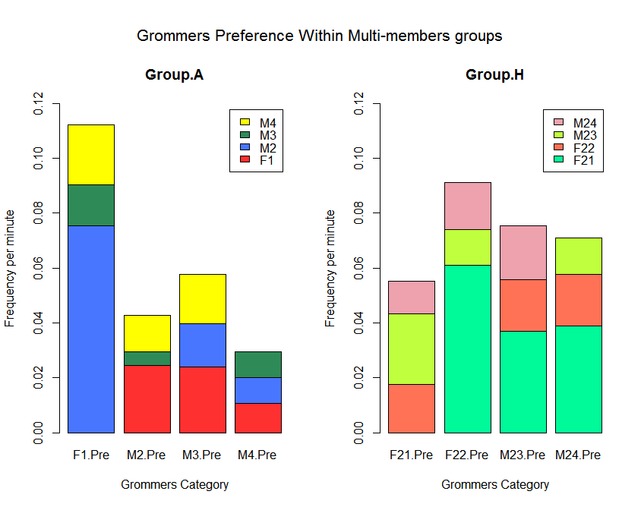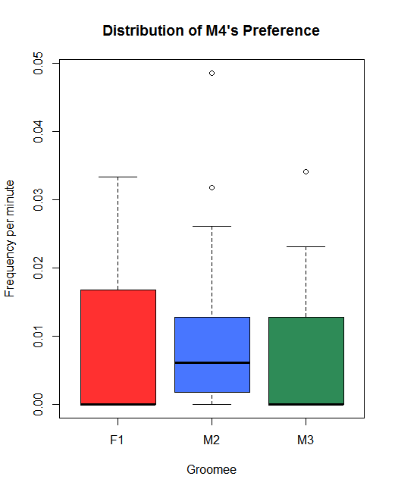

GraphB.1 GraphB.2

To answer the second question, group A and group H are investigated and each otter category is identified as groomer and labelled in horizontal axis while the vertical axis is the frequency per minute when they groom other otters within the group. In this case, I used stacked bar chart instead of grouped chart and although I am aware it would be less effective in judge’s opinion. However, if we are only trying to answer the question of whether or not the frequency is all equal in the group, the stacked bar chart is able to provide answer visually, and the length of each one is definitely differs from each other significantly. Except M4 (adult female) in group A and then I made another boxplot to further distinguish and the colours used are the same as Group.A in Graph B.1. The another big reason, I use this stacked bar chart is because it could briefly tells the difference between group A and group H. More specifically, the grooming rate is more frequent in group H and that might be caused by age effect, which offers me to examine it further. As a result, I try to break the old rules and use stacked bar chart. Introducing frequency per minute (grooming rate) would be suitable for comparison. The frequency per minute (also might refer as grooming rate in later part) is calculated as dividing its frequency by the observed time. In this case, it eliminates the concerns of uneven observed time. As a result, there is a unit measurement of observe times and frequency which is not biased, which would be intensively used in following section. It is noticeable that each bar has only three groomees that is because it is lack observation of self-grooming at least not in this dataset. The barplot is the optimal data visualization tool as it tells the preference directly and humans’ eyes are good at distinguishing long and short, while different colours indicate the various categories in this case. As shown in group A, it is obviously that otters exhibit their preferences towards otters, expect M4 shows relatively flat pattern preferences and but it still prefer little bit more towards F1. However, we could tell from Group A that male otters tend to groom female otters more, although this could be caused by uneven gender allocation and breeding season effect. When it comes to group H, we could tell that otters exhibit preference towards F21, subadult female otter, which raise the possibility of child-friendly grooming behaviour. Since subadult is not yet adult while younger adults already are, that is reasonable to predict that female subadult otters need extra care and help for grooming in this period. While subadult male (M23) shows the opposite direction, it is the last grooming option of young adult groups (F22 and M24). It shows joint factor of gender and age impact on grooming preference and that might be because they believe sub adult otters should develop its own independence of self-grooming. To answer the second question, individual exhibits preferences in who they groom in the multi-member group aggregately.

The previous two question are answered aggregated way without separating effects, also these two questions offer us to bread down further to see which factors should we explore into.

Section C. Overall Gender Effect on Grooming

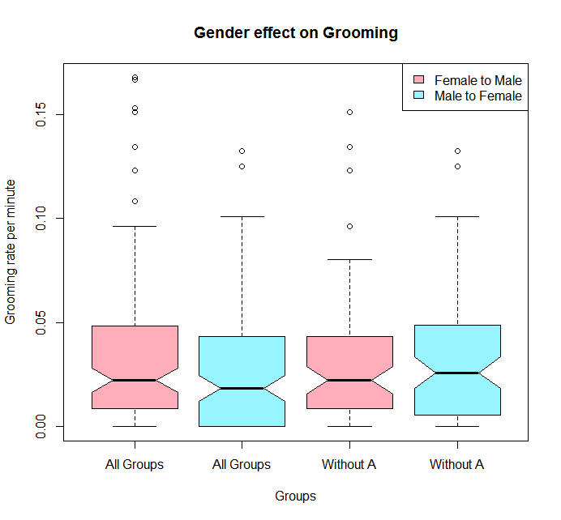

To answer the third question, whether or not female groom male more or other way around. The boxplot would be an optimal choice since it summarise and compare data for more sets, and colours I used to distinguish are both light and don’t make one of other big visually. From section A and B, it is believed that imbalance gender would lead to biased and different results. In this case, I present both of all groups and groups with group A’s statistics visualizations. In this case, “female to male” is identified when female otters are groomers and male otters are groomees, and “male or female” is another way around. Thus, when all groups involved, female tend to groom more for male, however excluding group A indicates a different results. Male otters tend to groom more for female otter. In this case, although without controlling any other factors, it is too arbitrary to conclude which gender is dominating in being groomed. We could only state that, based on balance number of female and male otters, male otters tend to groom more for female, mainly due to female otters have more responsibilities to raise offspring while male otters don’t.

Isolation Analysis

Section D. Other factors on affecting grooming behaviours and preferences

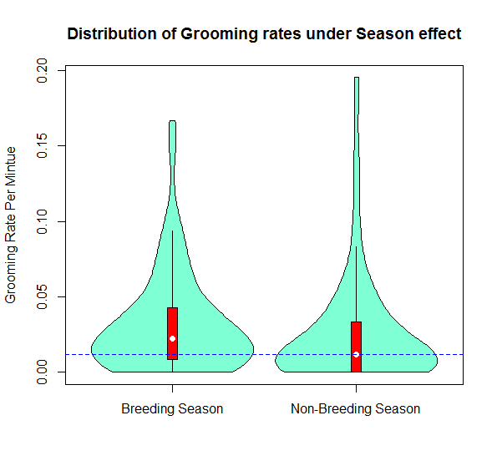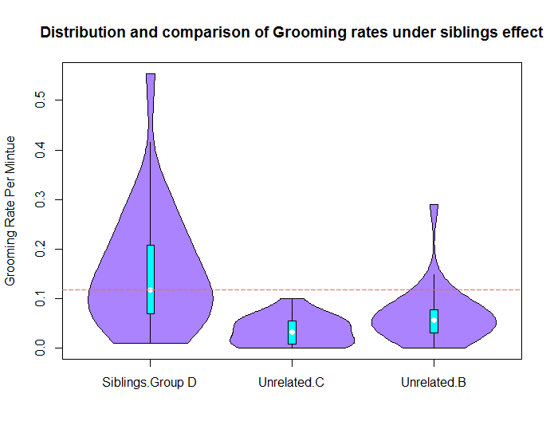

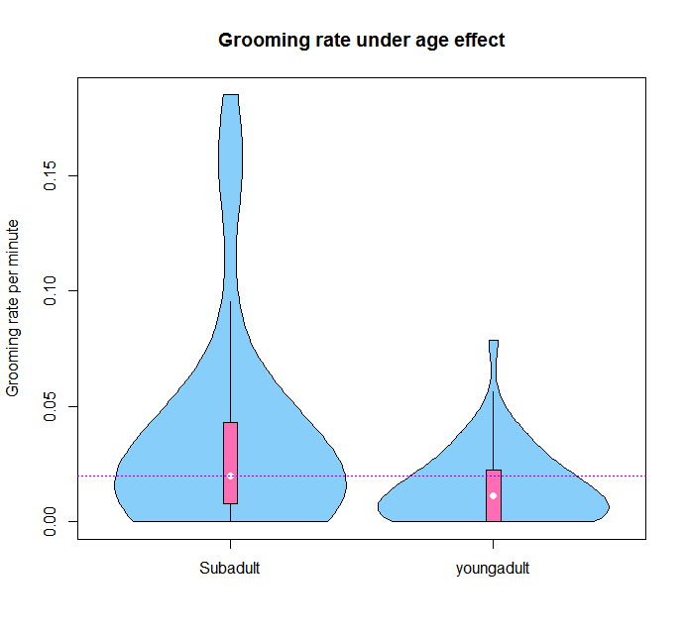

Graph D.1 Graph D.2 Graph D.3

After analysing three above sections and exploring different categories of dataset, apart from gender effect, there are three other effects would be highly suggested to investigate to explore their influence on grooming behaviour. Those three effects are season effect, sibling effect and age effect. In this case, I used violin plots as data visualization tool for story telling because violin plots provide both features of boxplot and density distribution. Exclusion of grooming rate with extreme observations are applied in three graphs to reduce skewness of distribution within reasonable scale, as a result, it makes comparison and observing easier. And grooming rates (frequency of grooming per minute) are the comparison unit since those effects are studied across group.

By aggregating breeding season effect, in other words only investigating grooming rate difference in breeding season and non-breeding season from the Graph D.1. It is reasonable to demonstrate that otters intend to groom more in breeding season and breeding season has certain impact on grooming behaviour, although magnitude is not large. Again, some many other factors are mixed across groups and we need to isolate them in more granular level to fully make conclusion.

Similarly, by aggregating sibling effect, I could identify how blood relation affects grooming behaviour. Group B and Group C are used as control groups since there is no identification of sibling effect. While Group H and Group A are both excluded since their age effect and imbalance of gender allocation respectively. As shown from Graph D.2, sibling relation has absolute effect on grooming rate, more specifically, the median and quantiles of group D is much higher and longer than that of group B and C. It is reasonable to predict that siblings tend to groom more their peers than those unrelated otters.

And last aggregated factor is the age effect which is studied solely within group H. In this case, I didn’t involve any adult group for now since those adults are not in the same group with subadult and young adult otter. Comparing with those adult group might affect my estimation, however, involving other adult groups have also been done in the latter section. Subadult in this case is defined when subadults otters are groomers and young adults otters are groomees. Similarly, young adults is defined as when young adults are groomer, the purpose of this setting is trying to observe the interaction between those two age groups. Surprisingly, subadults grooming more than young adult, which is different from presumption of child-friendly grooming behaviour observed from section A. However, there are breeding season and gender within this group and the effect might be overlapped by other effect.

All of three graphs highlights those factors have some influences and motivate us to explore in more granular level.

Section E. Isolating breeding and sibling effect

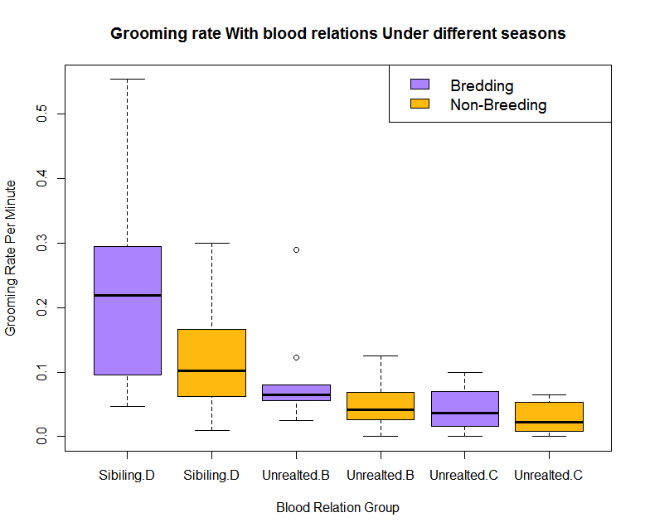

Since it is discovered that breeding and blood relation has influence on the grooming rate while those founding mixed with multiple effects, As a result, in this part, I try to isolate breeding effect and sibling effect and identify the difference. For grouping and clustering data group, boxplot is the ideal option to explore relation, and grooming rate is also used in y axis. As shown in the graph, otters tend to groom more in breeding season in regardless of sibling effect, although the horizontal label is not continuous variable but it shown in group category. More specifically, in group B, C and D, we all observe the decreasing pattern from breeding to non-breeding season. On the other side, without impacting of breeding season effect, the graph also shows that otters with sibling relations tend to groom more than unrelated otters in regardless of sibling effect. In other words, in both breeding and non-breeding season, siblings group tend to groom more than unrelated otter groups. In this part, it further supports that otters tend to groom more in breeding and also tend to groom more among sibling groups.

Section F. Isolating gendering and breeding effect

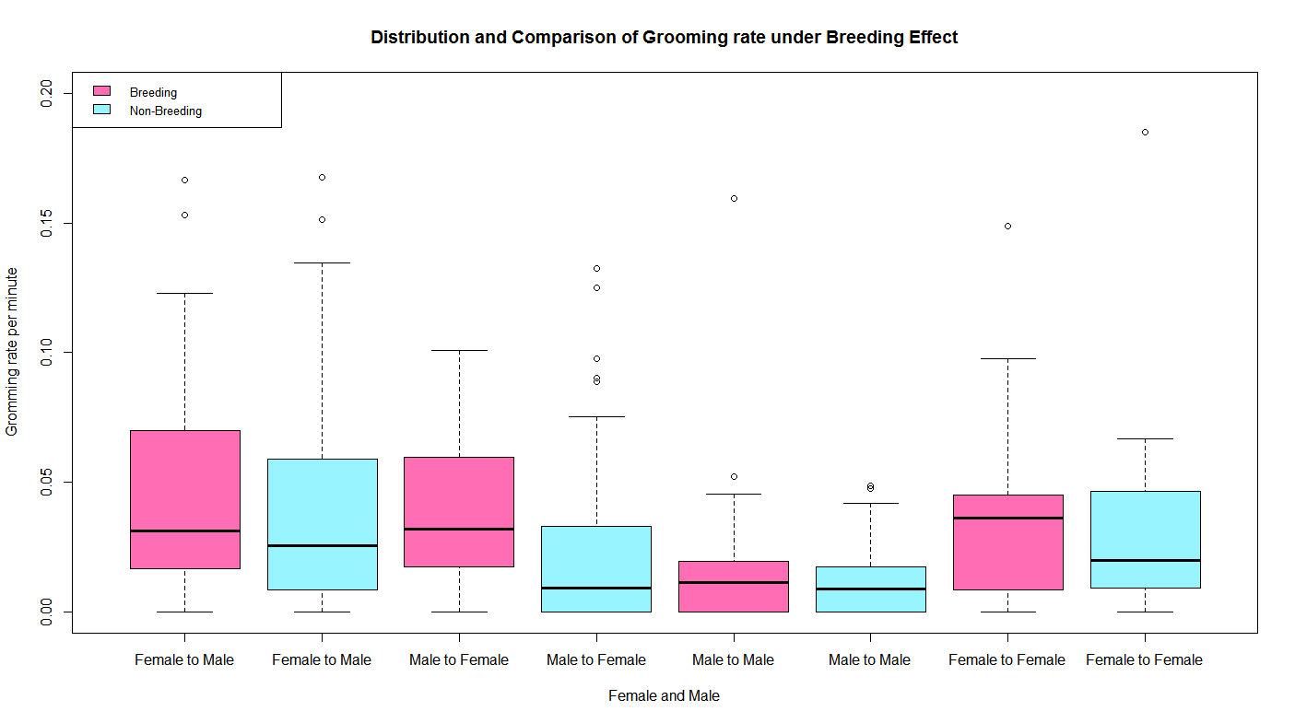

After isolating sibling effect, it is considered to isolate the gender effect and see whether or not it still show the same patter. In this case, I separate them into eight boxplots with four group categories, including grooming from female to male, male to female, male to male and female to female. By eliminating all the gender effect, in other words, without gender preference affect, we want to discover whether or not breeding still has the same effect. In this case, boxplot is still the ideal option to break down the pattern, and extreme values less than 0.2 grooming rate are excluded for better layout of visualization. As shown from the graph, all four groups, in regardless of gender effect, otters intend to groom more in breeding season than in non-breeding season. And male to male group shows the least variation under breeding effect, which makes sense there is no special needs and significant change in breeding season. Also, from the spread of boxplot and its median location, it is obvious that female tend to play a role of groomer more often as a groomee in either breeding season or non-breeding season. In other words, after exclusion of breeding effect, female intend to groom male more. What is more, it further answer fourth question, grooming rate did change in breeding season and it applied to all gender preferences( female to male, male to female, male to male and female to female). Also, by adding extra grooming behaviour between same gender effect, it is observable that male to male group is affected least by breeding season.

Section G Isolating Breeding Age, Gender preference

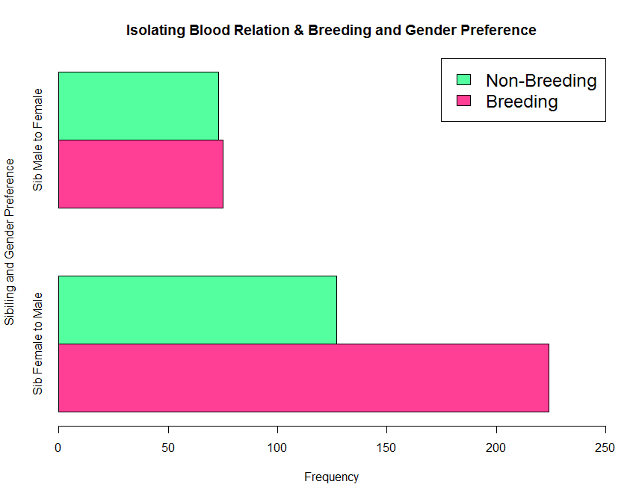

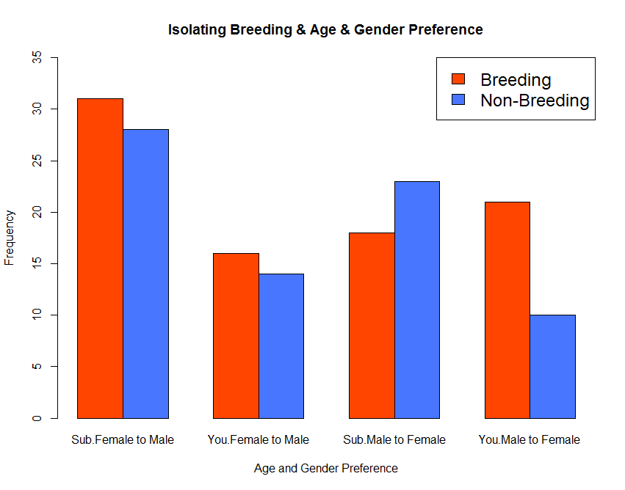

Graph G.1 Graph G.2

After exploring the breeding of siblings and gender preference, it would be more rigorous if we also go through age effect and explore further about the relationship of grooming rate between female and male, and also the breeding season effect.

In this case, since all the variables and observations we are clustering belongs to the same group. The measurement in this case will be just the frequency instead of grooming rate, as a result, the barplot and frequency offer a better visualization than boxplot and grooming rate. As shown in the graph, overall speaking, grooming rate is higher in breeding season expect for when subadult male groom for subadult female. That is the only group observed that grooming in non-breeding is more active than breeding season, which may mainly because sub adult is not yet sexually mature, there are more options for grooming in non-breeding season. In terms of which gender groom more, in subadult group, female tend to groom more for male in regardless of breeding effect. However, in young adult group, male otters tend to groom female otter more in breeding season but it shows opposite way in non-breeding season

Also, in this case, we explore Group D and isolate the sibling effect, in order to see how breeding effect and gender preference would react. Similarly, as the all otters are observed in the same group with same time, I use frequency as measurement units of grooming. As we expected and observed from Graph G.2, although the difference is small in male groom female, it still suggest that otters are general grooming more in breeding season. As in pink bar of female to male is longer than green one in both sibling groups. And for the statement of which gender grooms more, it suggests that in either breeding or non-breeding season, female otters groom male otters more.

Section H. Isolating breeding and gender effect, study for age effect

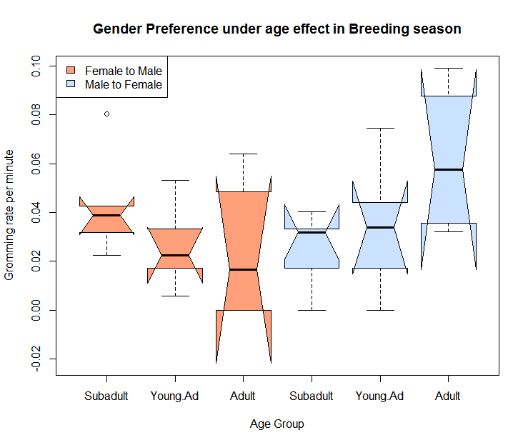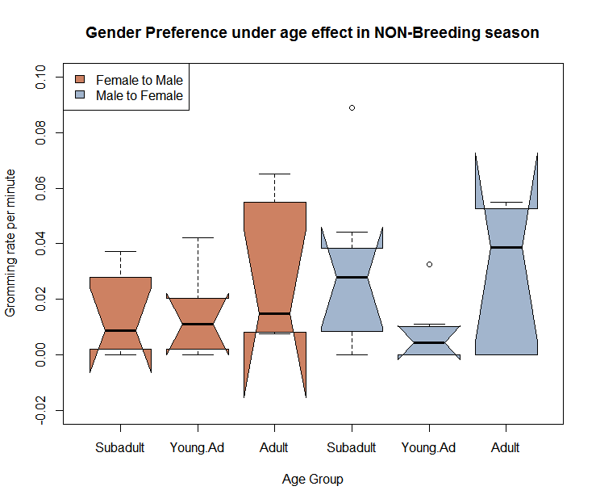

Graph H.1 Graph H.2

As discussed above, there are age effect on grooming rate and it seems that subadult otters tend to groom more than young adult otters and that comparison is not involved with adult group. In this case, by involving group C and isolating breeding effect, we are able to observe relationship between age and grooming rate. Involving C as a benchmark provides another age group with even number of male and female otters. As shown in the graph, when it comes to grooming from female to male, the grooming rate decreases with age increases. While, when male otters are groomers and female otters are groomee, it shows opposite direction, meaning that grooming rates increase with age increases. That might be caused by subadult is not adult and might not be sexually matured if we presumed grooming as a courtship behaviour. In other words, male otters might grooming more in breeding season for reproduction purpose. And subadult male otters are not yet sexually mature and it result in low grooming rate towards female otters, which is further validated by only small difference between subadult otter in regard of female or male as a groomer.

With that said, in this graph, we are also able to observe whether female otters groom male otter more or other way around under control of age effect and breeding effect. As mentioned, although subadult shows small difference but still female tend to groom more for male. However, this trend is reverse when age increases, showing that male tend to groom female more in breeding with age increases.

After reviewing those trend in breeding season, it is reasonable for us to check those effects in non-breeding season. Female to male shows different trend, indicating that in non-breeding season, grooming rate of female to male increase with age increases while young adult grooming rate shows relatively low. Young adult might not following the age effect or breeding season effect as others do.

Conclusion

After aggregately and separately analysed the dataset, there some factors is identified to have impact on grooming behaviours and preferences. Again, as mentioned, based on the only database and insufficient information, we are only able to observe correlation between variables instead of causation.

To answer four questions from project statement, and also some extra findings

1. Otters do have their own preferences towards who they are grooming within its own group

---More than half of female otters in total tend to be groomers.

1. In multi-members groups, individuals do exhibit their preferences

---Within the group of uneven numbers of male and female, female tend to groom male.

* Might because grooming is cement of social behaviour and competitive approach for breeding.

---Youngest female otters are acting as groomees frequently.

* Indicates grooming probably is a girl-friendly behaviour.

1. Female and Male grooming rate comparison.

--- When numbers of male and female otter are balance, male tend to groom female more

--- When all groups involved, after analysing breeding effect and sibling effect and age effect, female tend to groom male more. In other words, same pattern would exist with or without those effect.

--- Only young adult male tend to groom young adult female more.

1. Grooming rate changes in breeding season

--- Grooming rate between in four different categories changes in terms of season effect. (Four groups are female to male, male to female, male to male, female to female)

* The fluctuation of grooming rate between male and male is the smallest

--- Grooming rate generally increases in breeding seasons. Except for sub adult male groom female.

1. Grooming rates change in terms of sibling effect.

---Grooming rate increases when otters have blood relation.

---Grooming rate decreases between siblings in Non-breeding season

* Possibility of breeding between siblings.

1. Age has impact on grooming rate under breeding effect.

---In breeding season, with increases of age, the female to male grooming rate decreases, and male to female grooming rate increases.

---Also, grooming rate between male and male is the least affected

* Both of these highlight grooming is a courtship behaviour and is strongly behaved in male otters’ perspective.

To sum up those findings are, that female otters tend to play role as groomers while in young adult group, male tend to groom female more. Grooming is possibly a girl-friendly behaviour and courtship behaviour. Grooming rate is highly affected by sibling effect. Grooming rate is related to breeding season effect. And breeding between siblings are possible. And grooming rate is affect by solely season effect or solely age effect, but would be also affected by the combined effects.

(End of Project.B)